# “Design a pre-sales proposal for network setup in a university”

A COURSE PROJECT REPORT

By

**Rakshita Raj (RA2011030010030)**

**Harshitha G (RA2011030010020)**

**Devshree Moghe(RA2011030010049)**

Under the guidance of   
**Dr.P.Visalakshi***In partial fulfilment for the Course*

of

18CSC302J - COMPUTER NETWORKS

in Department of Network and Communications



**FACULTY OF ENGINEERING AND TECHNOLOGY SRM INSTITUTE OF SCIENCE AND TECHNOLOGY**

**Kattankulathur, Chenpalpattu District**

NOVEMBER 2022

**SRM INSTITUTE OF SCIENCE AND TECHNOLOGY**

**BONAFIDE CERTIFICATE**

Certified that this mini project report "**A pre-sales design proposal for network setup in a university** " is the bonafide work of **Rakshita Raj (RA2011030010030), Harshitha G (RA2011030010020) and Devshree Moghe(RA2011030010049)** who carried out the project work under my supervision.

# SIGNATURE

Dr.P.Visalakshi

# Rakshita Raj

# Harshitha G

Devshree Moghe

Department of Network and Communications

SRM Institute of Science and Technology

# ABSTRACT

A pre-sales design proposal for network setup in a university

The university has the following 7 departments.

1. IT  
2. Finance  
3. HR  
4. Management  
5. Faculty  
6. Students  
7. R&D

The university has an ADSL internet connection which would be used by the departments  
except for the R&D department which should not have access to the same. All the  
departments should be able to communicate with each other. Each department contains  
50-100 users.

# ACKNOWLEDGEMENT

We express our heartfelt thanks to our honorable **Vice Chancellor Dr. C. MUTHAMIZHCHELVAN**, for being the beacon in all our endeavors.

We would like to express my warmth of gratitude to our **Registrar Dr. S. Ponnusamy,** for his encouragement

We express our profound gratitude to our **Dean (College of Engineering and Technology) Dr. T. V.Gopal,** for bringing out novelty in all executions.

We would like to express my heartfelt thanks to Chairperson, School of Computing **Dr. Revathi Venkataraman,** for imparting confidence to complete my course project

We wish to express my sincere thanks to **Course Audit Professor Dr.Annapurani Panaiyappan, Professor and Head, Department of Networking and Communications** and **Course Coordinators** for their constant encouragement and support.

We are highly thankful to our my Course project Faculty Dr.P.Visalakshi**, Assistant Professor(Selection Grade) , Department of Network and Communications,** for his/herassistance, timely suggestion and guidance throughout the duration of this course project.

We extend my gratitude to our **HoD Dr.Annapurni Pannaiyapan K., Professor and HOD, Department of Networking and Communications** and my Departmental colleagues for their Support.

Finally, we thank our parents and friends near and dear ones who directly and indirectly contributed to the successful completion of our project. Above all, I thank the almighty for showering his blessings on me to complete my Course project.

**TABLE OF CONTENTS**

## CHAPTERS CONTENTS PAGE NO.

* + - 1. **ABSTRACT**
      2. **INTRODUCTION**
      3. **LITERATURE SURVEY**
      4. **REQUIREMENT ANALYSIS**
      5. **ARCHITECTURE & DESIGN**
      6. **IMPLEMENTATION**
      7. **EXPERIMENT RESULTS & ANALYSIS**
         1. RESULTS
         2. RESULT ANALYSIS
      8. **CONCLUSION & FUTURE ENHANCEMENT**
      9. **REFERENCES**

1. **INTRODUCTION**
   1. **Scenario Description**

A network has to be designed for a university which has 50-100 users in each department. It is a pre-sales network setup in which various computers of different departments are set up so that they can interact and communicate with each other by interchanging data. To design a networking scenario for a college which connect various departments to each other’s, it puts forward communication among different departments.

The students and faculties in the organization will be able to use the server without any restriction since they are directly routed to the same network via the campus server. The departments can also intercommunicate with one another without any restriction.

The main objective of the proposed network is to update the existing network and also enhance

its capabilities and increase the flexibility of the network which will eventually provide good

security.

ording to (Fortier & Michel, 2003), computer architecture, operating system, database and LAN

represent elements for improvement of efficiency of application execution. In case of improper use,

efficiency might be reduced. Computer systems based on decentralized, parallel and distributed

architectures are constantly being designed and brought into use (Lowekamp, 2003). Computer system

components have become more complex, and at the same time requests referring to reliability and

availability are higher, as in (Jain and Dovrolis, 2003) (Egyhazy and Yao, 2007).

ortier & Michel, 2003), computer architecture, operating system, database and LAN

represent elements for improvement of efficiency of application execution. In case of improper use,

efficiency might be reduced. Computer systems based on decentralized, parallel and distributed

architectures are constantly being designed and brought into use (Lowekamp, 2003). Computer system

components have become more complex, and at the same time requests referring to reliability and

availability are higher, as in (Jain and Dovrolis, 2003) (Egyhazy and Yao, 2007).

ortier & Michel, 2003), computer architecture, operating system, database and LAN

represent elements for improvement of efficiency of application execution. In case of improper use,

efficiency might be reduced. Computer systems based on decentralized, parallel and distributed

architectures are constantly being designed and brought into use (Lowekamp, 2003). Computer system

components have become more complex, and at the same time requests referring to reliability and

availability are higher, as in (Jain and Dovrolis, 2003) (Egyhazy and Yao, 2007).

ortier & Michel, 2003), computer architecture, operating system, database and LAN

represent elements for improvement of efficiency of application execution. In case of improper use,

efficiency might be reduced. Computer systems based on decentralized, parallel and distributed

architectures are constantly being designed and brought into use (Lowekamp, 2003). Computer system

components have become more complex, and at the same time requests referring to reliability and

availability are higher, as in (Jain and Dovrolis, 2003) (Egyhazy and Yao, 2007).

ortier & Michel, 2003), computer architecture, operating system, database and LAN

represent elements for improvement of efficiency of application execution. In case of improper use,

efficiency might be reduced. Computer systems based on decentralized, parallel and distributed

architectures are constantly being designed and brought into use (Lowekamp, 2003). Computer system

components have become more complex, and at the same time requests referring to reliability and

availability are higher, as in (Jain and Dovrolis, 2003) (Egyhazy and Yao, 2007).

ortier & Michel, 2003), computer architecture, operating system, database and LAN

represent elements for improvement of efficiency of application execution. In case of improper use,

efficiency might be reduced. Computer systems based on decentralized, parallel and distributed

architectures are constantly being designed and brought into use (Lowekamp, 2003). Computer system

components have become more complex, and at the same time requests referring to reliability and

availability are higher, as in (Jain and Dovrolis, 2003) (Egyhazy and Yao, 2007).

ortier & Michel, 2003), computer architecture, operating system, database and LAN

represent elements for improvement of efficiency of application execution. In case of improper use,

efficiency might be reduced. Computer systems based on decentralized, parallel and distributed

architectures are constantly being designed and brought into use (Lowekamp, 2003). Computer system

components have become more complex, and at the same time requests referring to reliability and

availability are higher, as in (Jain and Dovrolis, 2003) (Egyhazy and Yao, 2007).

ortier & Michel, 2003), computer architecture, operating system, database and LAN

represent elements for improvement of efficiency of application execution. In case of improper use,

efficiency might be reduced. Computer systems based on decentralized, parallel and distributed

architectures are constantly being designed and brought into use (Lowekamp, 2003). Computer system

components have become more complex, and at the same time requests referring to reliability and

availability are higher, as in (Jain and Dovrolis, 2003) (Egyhazy and Yao, 2007).

ortier & Michel, 2003), computer architecture, operating system, database and LAN

represent elements for improvement of efficiency of application execution. In case of improper use,

efficiency might be reduced. Computer systems based on decentralized, parallel and distributed

architectures are constantly being designed and brought into use (Lowekamp, 2003). Computer system

components have become more complex, and at the same time requests referring to reliability and

availability are higher, as in (Jain and Dovrolis, 2003) (Egyhazy and Yao, 2007).

ortier & Michel, 2003), computer architecture, operating system, database and LAN

represent elements for improvement of efficiency of application execution. In case of improper use,

efficiency might be reduced. Computer systems based on decentralized, parallel and distributed

architectures are constantly being designed and brought into use (Lowekamp, 2003). Computer system

components have become more complex, and at the same time requests referring to reliability and

availability are higher, as in (Jain and Dovrolis, 2003) (Egyhazy and Yao, 2007).

**3.REQUIREMENTS**

* 1. **Requirement Analysis**

1. The active network components which are required ( Routers , Switches ).

2. Given the number of switches , routers which are required for the design.

3. The IP Design schema for the department.

4. Explained about other details required to be configured on the Switch and how to  
create different departments with VLAN.

5. Explanation of how to restrict internet connection for R&D Department and allow

access for the other departments with Access control lists on the Router.  
6. Identifying the feature on the router which is required for sharing the Internet for the  
users.

7. Identifying the TCP/IP adapter parameters ( IP address, Subnet mask, Default  
Gateway, DNS Server IP address) for the users.

1. **ARCHITECTURE AND DESIGN**
   1. **Network Architecture**

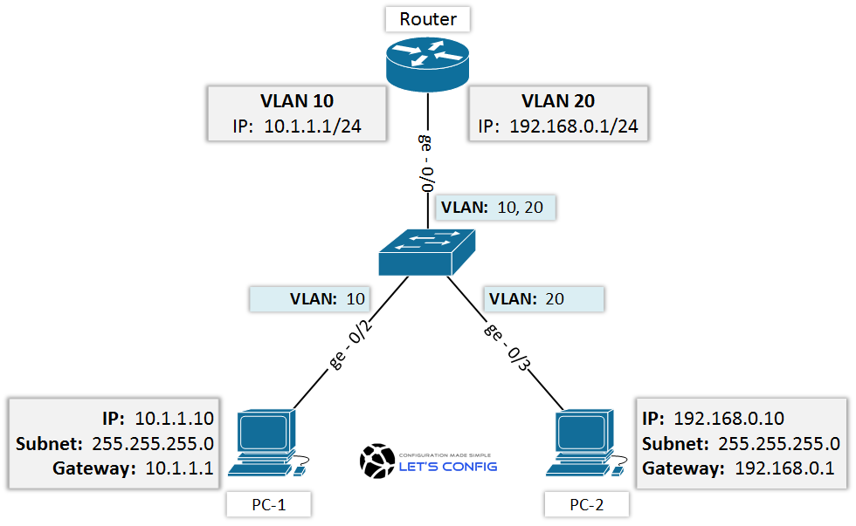

Usual vlan setup for connection between users or pc’s

The network architecture is as follows:

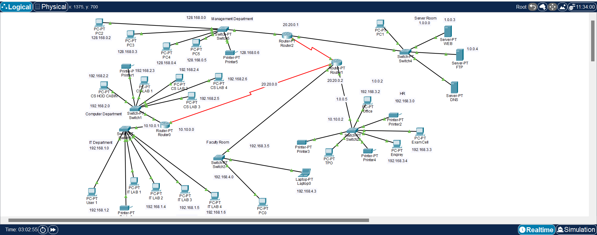

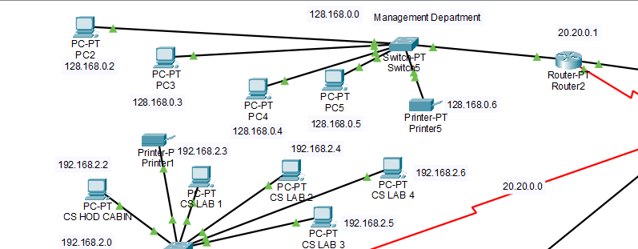

Management Department

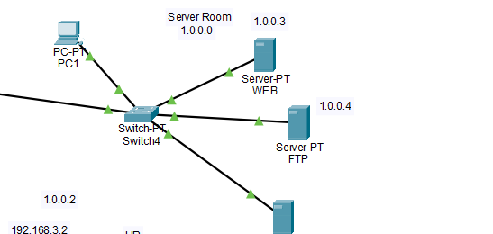

Server Room

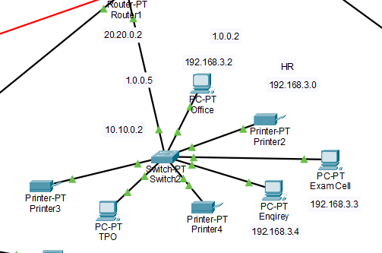

HR Department

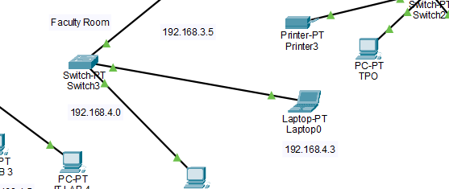

Faculty Room

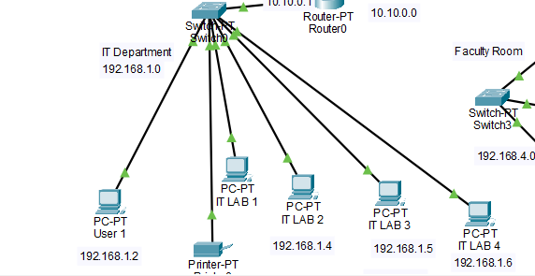

IT Department

The architecture consists of server room which has a switch connected to a router.

Every department has one switch connected to two routers except the management department through serial connection.

These networks are interconnected with each other with varying degrees

ADSL or DSL connection is used to establish a communication between the different departments and with the department and the server.

1. **IMPLEMENTATION**
   1. **Address Table**

The address table is as follows:

|  |  |  |
| --- | --- | --- |
| **Device** | **Interface** | **Address** |
| Server | Fa0 | 1.0.0.0 |
| Management Department | Fa0/0 | 172.16.0.1 |
| Fa1/0 | 192.16.0.1 |
| Se2/0 | 10.0.0.1 |
| Finance Department | Fa0/0 | 192.16.0.2 to 192.16.0.7 |
| It Department | Se2/0 | 10.0.0.2 |
| Fa0/0 | 192.168.10.1 |
| Faculty | Fa0/0 | 192.168.4.0 |
| HR Department | Fa0/0 | 192.168.3.0 |

1. **RESULTS AND DISCUSSION**
   1. **Connection Check**

The network connections were checked by ping requests:

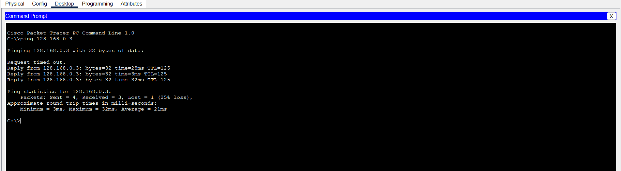

**Communication between user of it department and management department**

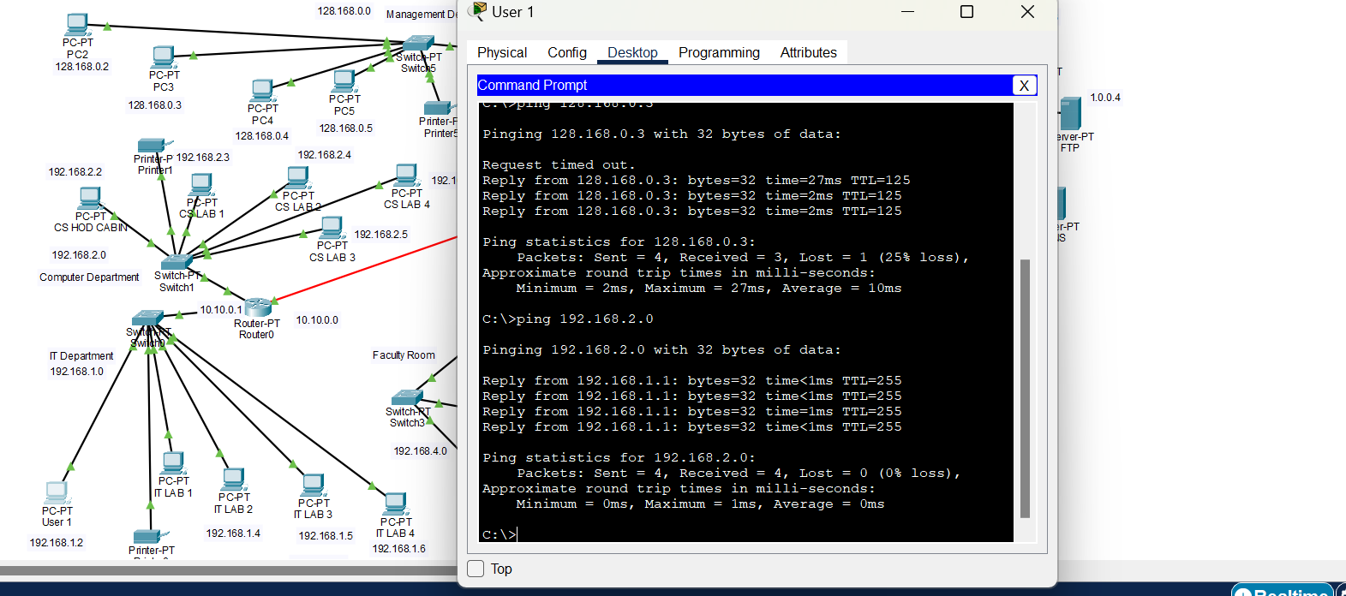

**Communication between it and computer department**

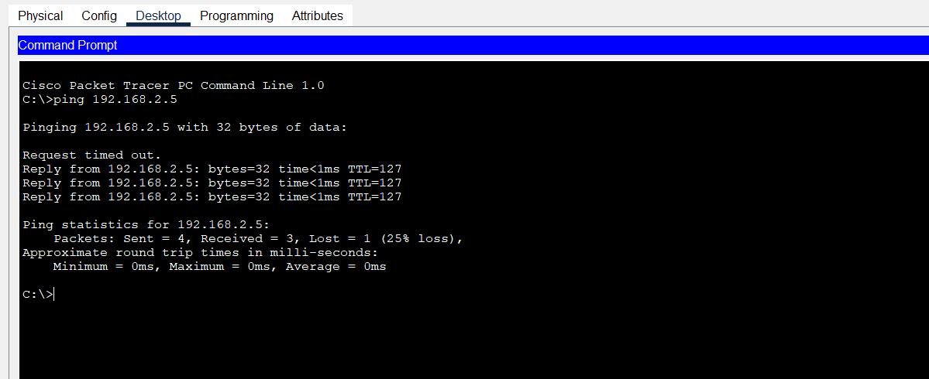

User from IT department pinging with a user from finance department

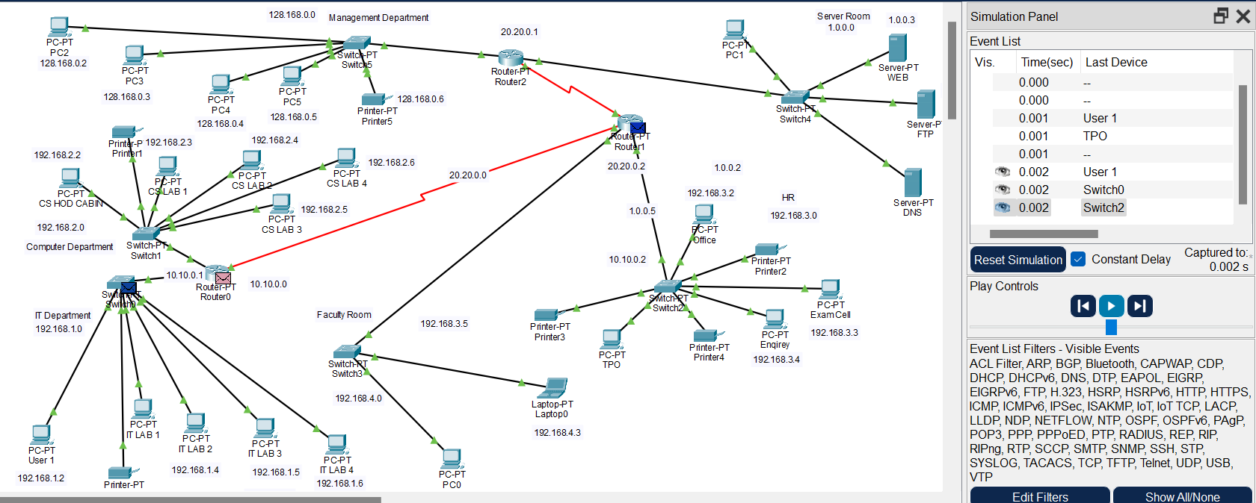

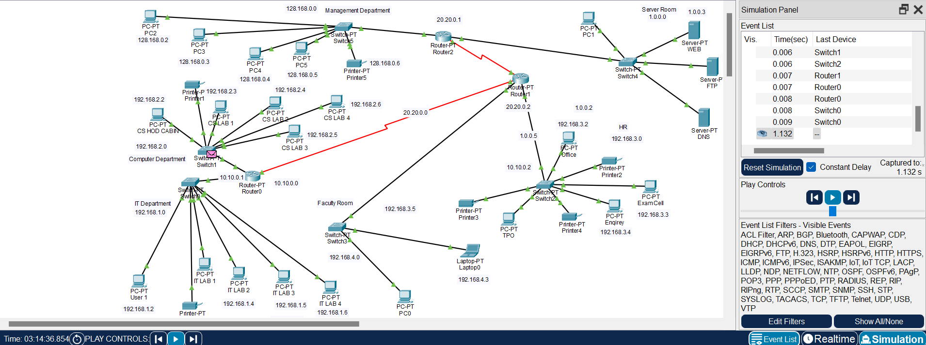

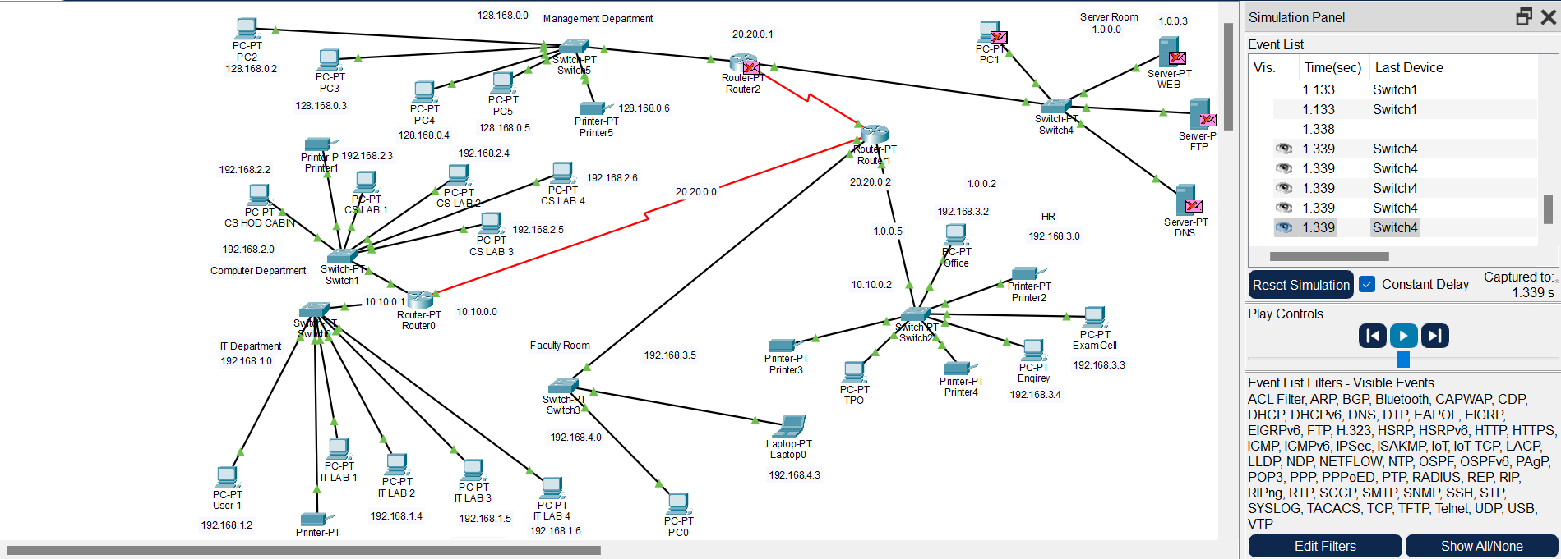

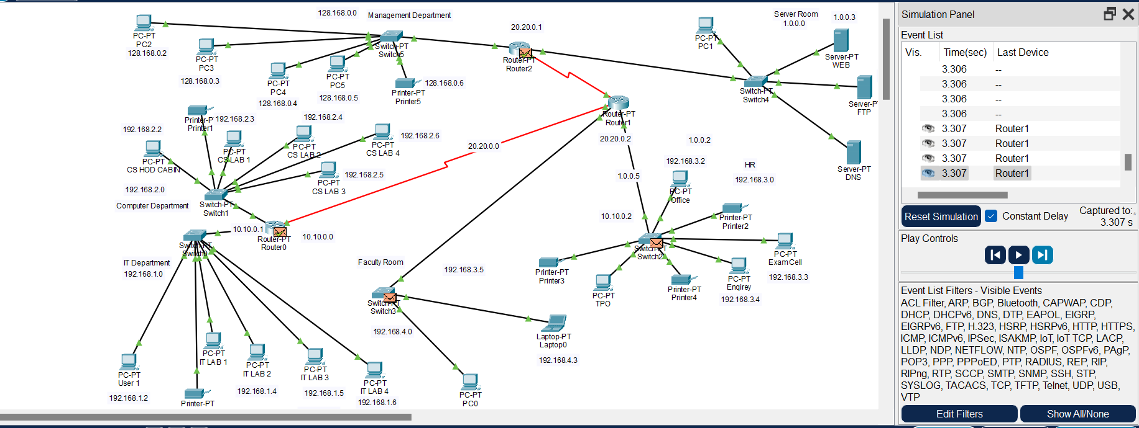

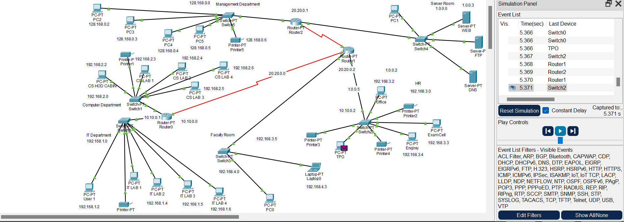

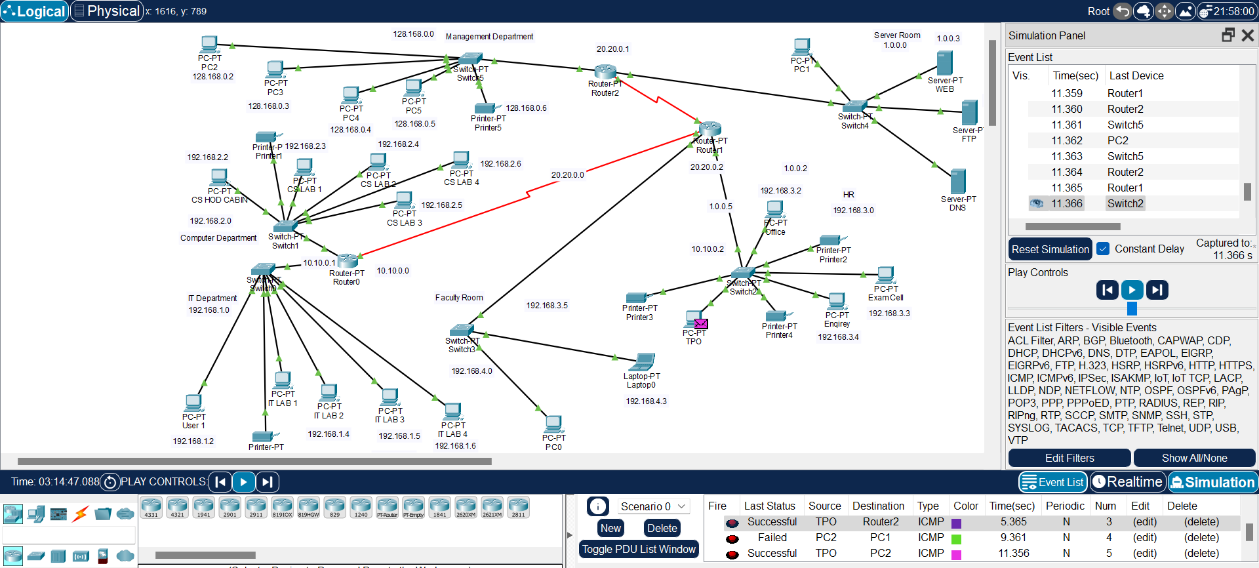

Tracing from hr department to management department

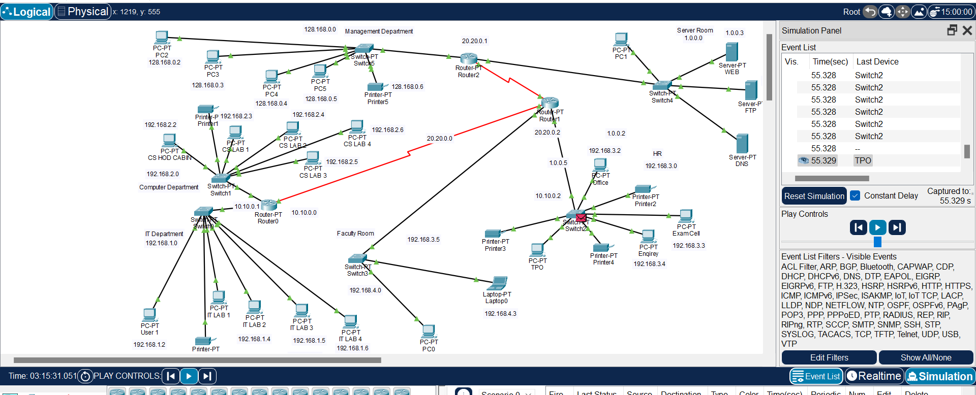

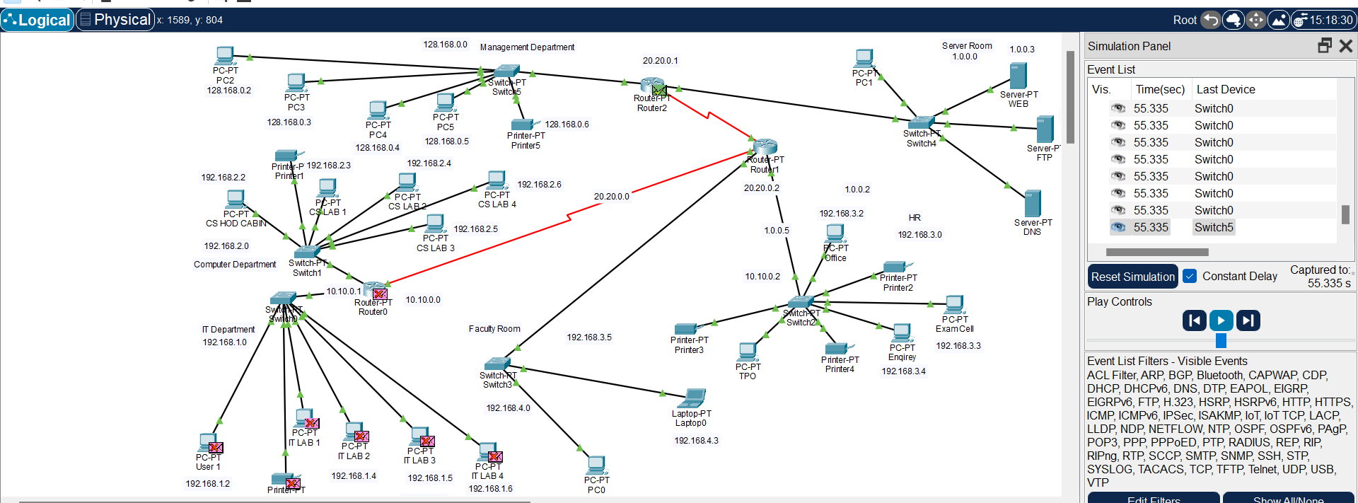

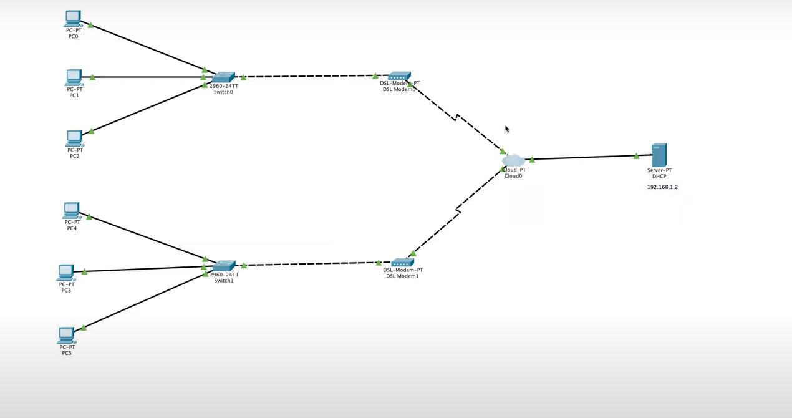

**DSL is configured**

**ADSL/DSL connection:**

DSL is a cost-effective method to connect to the internet with high speed bandwidth, as compared to cellular data. It’s much faster than a dial-up connection with a high bitrate. DSL speeds vary from 256 Kbps to 100 Mbps. Internet providers have various packages depending on the connection speed you need.

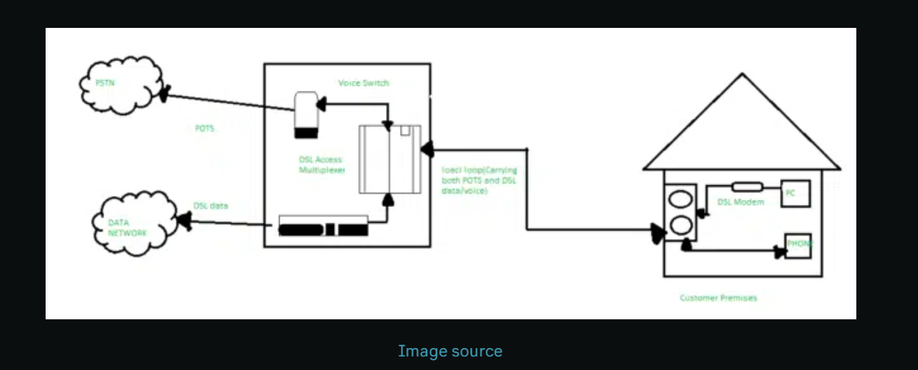

## ****DSL vs cable****

### **Structure**

Cable internet is a type of [**broadband internet connection**](https://www.ringcentral.com/gb/en/blog/ultimate-guide-to-broadband-for-your-home-office/) that uses coaxial cables to connect you to the internet. It uses the same infrastructure as cable television, quite analogous to a DSL service using telephone lines. Cable internet is popular among residential users and one of the cheaper options.

### **Availability**

Cable internet is almost as easily available as DSL. It’s widely accessible because of the reach of cable television especially in urban and suburban areas. You can easily find packages bundled with your cable TV monthly subscription.

There might be availability issues in rural areas. DSL comes to the rescue there because telephone lines have reached where cable still has not.

### **Reliability**

Speed reliability can be a concern with cable internet. Cable internet uses a shared network and the coaxial cables are susceptible to network congestion. This can lead to slowed speeds and performance can dip during peak times.

### **Speed**

It’s among the fastest internet types out there. Download speeds can go up to 1 Gbps and upload up to 50 Mbps.

Many people opt for a DSL connection because it’s widely available. Fibre optic is mostly available in urban areas and tech hubs. Cable internet is also available but not preferred to DSL because DSL is more dependable. It’s hard to give the broadband crown to DSL or cable, because while DSL can be easier on the pocket, cable can be faster.

Depending on what’s offered where you live, fast reliable internet is easily achievable these days. Between DSL, cable internet, fixed wireless internet, and fibre optic, you have the option to find the perfect internet connection for your home or business. Just do your homework before taking the plunge.

DSL brings a connection into your home through telephone lines and allows the household to use the Internet and make telephone calls at the same time. It works because the DSL system separates the telephone signals into three bands of frequencies. The lowest band allows for telephone calls, while the other two bands take care of uploading and downloading online activity.

Cable companies provide a cable modem for their Internet customers. DSL companies provide a similar piece of hardware called a DSL transceiver.

Since DSL uses telephone wires, it makes sense that the biggest providers are telephone companies. AT&T is the largest telecommunications company in the world and is also the largest provider of DSL service. Verizon and Century Link are also major providers of DSL.

[ADSL](https://www.southern-comms.co.uk/data/adsl-broadband/) is a popular, older type of broadband, with the term standing for Asymmetric Digital Subscriber Line. It is a broadband connection that works through the copper wires of existing phone lines and is mainly used for home broadband and within small businesses.

1. Runs through the BT phone line network
2. High-quality, reliable broadband connection
3. Permits faster data transmission through a single connection
4. Allows internet access at the same time as making phone calls
5. Minimal installation costs and maintenance

ADSL broadband is an extremely cost effective way to access the internet and is the most useful for startups and small businesses who have low reliance on the technology. Perhaps only one call needs to be made at a time and the business owner is often online at off-peak times.

For such businesses, ADSL is a fantastic entry level broadband that allows for easy budgeting; it won’t have a huge impact on finances and forecasts. With speeds of up to 24Mbps download and 8Mbps upload, it can be more than enough for your needs. When this is the case, it’s a wise business decision to not pay for more than you need and to reinvest the savings into your success.

Should your business still be using a dial-up modem, it is recommend to switch to broadband to benefit from fast internet access that’s always on, to help improve productivity. To access ADSL once it’s installed, you need an ethernet cable and router, which also enables a WiFi connection.

How does ADSL broadband work?

To set-up an ADSL broadband connection, an existing phone system is connected to the BT line through copper wires. During installation, a DSL (Digital Subscriber Line) filter, or splitter, isolates frequency bands allowing a single line to be used for both telephone calls and ADSL broadband.

Due to how ADSL is accessed, performance is affected by distance from the PBX, or Private Branch Exchange. The closer premises are to the exchange, then the better the performance received as the connection benefits from a stronger signal. This is known as an asymmetric flow of data.

In the immediate vicinity of the exchange, users will get a high speeds (up to 24Mbps) and those towards the edge of the signal range will get lower rates of speed (down to 1Mbps). Estimated speeds can be checked before installing the connection.

ADSL is also not exclusive; it is known as a contended service where usage is shared between other businesses and home users in your area. It’s performance will slow down at peak times of usage.

1. **CONCLUSION AND FUTURE ENHANCEMENT**

Thus the pre sales network setup for a university/campus was successfully implemented. Through this proposed setup we get a visual perspective on how to create connections for various departments of a university.

The outcome of the proposed system will be a fail-safe backbone network infrastructure which meets the requirements for readily available access to information and security of the private network, and also ensures optimized productivity when telecommunication services are accessed. The installed equipment allowed to organize high-speed wired and wireless Internet access throughout the whole complex of hospital buildings as well as providing transfer of all types of data throughout the single optimized network.

In most scenarios, you’d likely want DSL only if your other alternative were old-fashioned, low-cost dial-up service, which surprisingly is still available in many areas. Compared to dial-up, DSL offers you advantages:

1. You’re able to use the Internet and make phone calls simultaneously.
2. It’s faster than dial-up.
3. You have a choice of price plans, based on the speed you want or are willing to get.

That seems like a good start, but there are some disadvantages nonetheless:

1. Sending data won’t work as well or as fast as receiving data.
2. The further you are from the telephone company’s central location, the slower your service might be (we’re not talking hundreds of miles either—more like just under four miles).
3. Sorry. You just might be too far away to even be offered DSL.
4. [The increasing reliance on fiber optics](https://www.insidetelecom.com/telecoms/fibre-connections-are-on-the-rise/), highlighted through the big investments communications service providers are dedicating to strengthen their infrastructure, has been the main driver away from DSL services. The properties of optical transmission in terms of speed, low interference and attenuation have been appealing to individuals and companies. The deployment of a fiber network that reaches all premises constitutes a last-mile connectivity to the global fiber optic network.  The difference in user experience perceived by subscribers is the main reason to switch from aging DSL connections.

### 5G Wireless Networks

5G is the talk of the town! Everyone from standardization bodies to governments, network operators, businesses, and individuals are talking about the properties of the new technology. 5G is not only a new standard that should provide higher data rates and lower latencies. [It is rather a complete ecosystem](https://www.insidetelecom.com/technology/the-trinity-of-future-5g-blockchain-and-iot/) that is meant to transform how services are conceived and provided.  The adoption of true versatile mobile connectivity that started with 3G should be amplified further with 5G. Subscribers are relying more on their mobile devices to perform most of their daily tasks, and DSL is simply not adequate for that. In addition to enabling mobile broadband connectivity, new 5G fixed wireless access solutions are being developed to provide high speed fixed broadband connectivity.

### Cable Internet Connectivity

Cable internet is yet another alternative to DSL. Instead of relying on copper-based telephone lines, cable solutions use the television cable infrastructure to provide internet connectivity. As TV transmission only consumes a small part of the bandwidth, service providers are able to deliver high speed internet over the link.

**REFERENCES**

1. <https://www.youtube.com/watch?v=e1cD2KIme-E&list=PLyEymK89ZUabd7h9FK4dGVdONbxFEJoyk&index=4>
2. <https://skillsforall.com/course/getting-started-cisco-packet-tracer>
3. <https://www.youtube.com/watch?v=u2eJdE9MxL8>
4. <https://www.techtarget.com/searchnetworking/definition/ADSL#:~:text=ADSL%20(Asymmetric%20Digital%20Subscriber%20Line)%20is%20a%20technology%20that%20facilitates,%2C%20always%2Don%20broadband%20connections>.
5. <https://www.geeksforgeeks.org/router-configuration-with-cisco-packet-tracer/>
6. <https://www.youtube.com/watch?v=ZMC1YJB8CLs>
7. <https://www.youtube.com/watch?v=vcNhIl4DMX0&ab_channel=Tanvir%27sAcademy>
8. https://github.com/topics/computer-networks-project